|  |
| --- |
| American Video Game Company |
| Software Project Template |
| Project Automata |
| Mike Tillotson  4-1-2019  Version 1.10 |

Contents

1. Introduction 3

1.1. Overview of Issue 3

1.2. Goals and Objectives 3

1.3. Prerequisites 3

1.4. Scope 3

2. Requirements 4

2.1. Business Requirements 4

2.2. User Requirements 4

2.3. Functional Requirements 4

2.4. Nonfunctional Requirements 4

3. Development Process 5

3.1. Advantages of the waterfall method 5

3.2. Disadvantages of the waterfall method 5

3.3. Best suited 5

4. Design 6

4.1. Storyboard or Flowchart (Change title to fit needs) 6

4.2. UML Diagram (Change title to fit needs) 7

4.3. GUI (Change title to fit needs) 8

5. Testing 9

5.1. Unit Testing 9

5.1.1. Test Name 1 9

5.1.2. Test Name 2 9

5.1.3. Test Name 3 10

6. Sources 12

# Introduction

A CRM is a set of tools used for managing a company’s varied relationships and interactions with their customers and possible future customers. A CRM tool allows for a more streamlined organization of individual and corporate contacts such as customers, external colleagues, vendors and even service users. For AVG(American Video Game) the use of the popular tool Salesforce would allow for a preloaded fully functional tool that can accommodate our growing business needs.

# Purpose Statement

This document exists to convert the CRM requirements provided by our business case into specific deliverables that can be brought to fruition during the implementation lifecycle. The succeeding page will document test plans as well as how to quality control the deliverables.

# Overview of THE PROBLEM

The major issue facing us relating to this project is one every company should aspire to have. Things are going too well. Our company sales have grown by 42% over the past two years and we anticipate future growth. However in order to properly nourish this growth the implementation of a new CRM system, which Salesforce is the ideal candidate.

# Goals and Objectives

The major goal of this project is simply stated. To effectively and seamlessly integrate the Salesforce service into our existing applications, and simultaneously phase out our existing software. The goals for the new system are as follows:

* Reliable Function
* High Quality Performance
* Scalability for future growth
* Security for sensitive data

The completion of the above listed goals is crucial for a system that meets our objectives. The primary being the implementation of a system that can merge all of our contact and business information into a single database system, which will also handle activity tracking with our contacts. The system must also have granular security permissions based on pre built roles and permissions for the created users, whether they be internal employees or external contractors or marketers.

# Prerequisites

Outline any aspects that need to be in place prior to the design, development, and implementation of the project proposed in this document. Be sure to be clear and concise for all listed prerequisites. Also, clearly outline why each prerequisite is needed.

|  |  |  |  |
| --- | --- | --- | --- |
| Number | Prerequisite | Description | Completion Date |
| 1 | Data Sanitization | As our current CRM process involves a series of disconnected spreadsheet tools and DBMS software, it is crucial that the data stored in these processes be sanitized in such a way that it can be easily imported into Salesforce when the environment goes live. This means bringing all contact data into one location and unifying the required fields, separating out business contacts from individuals, sorting them by their purpose be it marketing contracts or sales. This must be done before Salesforce goes into a production environment otherwise there will be no usable data in the system itself. | Prior to Production environment |
| 2 | Role Creation | For security purposes, each user should only be granted role access within the needed groups and areas required to perform their job duties. While Salesforce comes with a certain amount of OOTB roles configured, these must be examined and if necessary expanded on to ensure that each user is granted their needed access and no more. This is a core tenant of our role based security policy. | Before Production Release |

# Scope

Salesforce as an application has the capability to expand to fit a variety of our service needs both now and in the future. However the focus of it’s implementation for this project will be as a replacement system for our existing CRM software. The set purpose of this project will be to implement the Salesforce tool piece by piece. It will cover the import and consolidation of our business contact information, which will include the activity management piece of the project covering company interaction with these contacts and sales tracking. This project will also cover the creation of the necessary security roles in order to ensure the right feature access is given to the correct individuals. Though the system will be built with scalability in mind, at this time we will not be implementing some of the other optional features Salesforce offers such as their service hub designed around creating a help desk portal. This project will be strictly focused on bringing Salesforce online as a unified replacement for existing processes.

# Environment

Since CRM Salesforce is a hybrid environment a robust server system is not required. However a strong network will need to be implemented as well as proper security as we will be passing data to a cloud environment. As much of our existing tools are spreadsheet and DBMS software it’s likely one of the biggest hurdles will be homogenizing and incorporating this data into Salesforce.

# Requirements

# Business Requirements

The Salesforce tool will act as a central Activity Management hub, which includes managing Sales, Business Contacts, and any sort of overt communication. As part of this the Sales Hub will link with our Exchange servers to allow direct email from the portal. It also allows for a sync with our Active Directory server, which means that new employees will be automatically added into the system every time the sync is run. It also contains the ability to send personalize though automated responses as needed to keep in contact with current and future clients.

Another Business requirement are the reporting tools available. It is desired to be able to not only generate current sales data, be it pricing catalogs, inventory lists, or sales data; but also to be able to generate forecasting data, such as the application of currency adjustments or product forecasting. Salesforce comes with an extremely robust Reporting suite, that, once the data has been properly imported can begin generating the desired information. There are several options that can be created. Fom manual reports built by approved users, to general dashboard reports seen whenever one logs in, even automatically generated reports that can be sent out to a list of contacts within Salesforce at specific times.

# User Requirements

The system must be accessible across all standard browser and mobile platforms. It must work within the existing security structure of the business, and effectively move between the hosted cloud and local server environments. There must be plentiful space for historical data of multiple types, and it must have the ability to generate quotes and forecast sales data. These requirements will be relatively simple to achieve, as the Salesforce exists natively in a hybrid environment, and as such its developers have ensured that it is available across all platforms, including a free mobile app that can be synced with our specific virtual servers.

# Functional Requirements

This application’s primary purpose is to manage our business contacts and the information relating to our business with them. With the implementation of Salesforce that process will become more unified and easier for all team members to use. Given its hybrid nature, the issue of different tools being used across different offices or among our remote team members will no longer be an issue. All contacts and order information will be located in a single unified hub, Salesforce. Salesforce allows for contacts to be organized on an account, Company, or individual level, allowing for grouping as needed. There is also the ability to maintain our contracts with these businesses be they customer or contractor within Salesforce.

# NonFunctional Requirements

The system must have an efficient import/export system for the data, along with minimal risk validation to prevent duplicate records from being created. This is primarily accomplished through Data Loader, which was mentioned previously. This application makes the bulk import and export of data a simple process, and it can be accessed either on a technical (Command Line) level, or as a simple user interface into or from a csv file, supporting files as large as 5 million records.

# SOFTWARE DEVELOPMENT METHODOLOGY

The company has selected the waterfall software development methodology for this project. Examine the waterfall methodology and compare it to other software development methodologies (e.g., Agile). Include a brief introduction to the development process as well.

# Advantages of the waterfall method

For this project the waterfall methodology will prove quite effective, as instead of building a system we are implementing an already developed and robust system. Since the requirements are known in advance and are unlikely to shift much during the implementation phase, this single sequential process will be the most effective method of implementing Salesforce.

This compares to the more iterative Agile process. While certain facets of Agile methodologies may prove valuable, particularly in the verification phase, this methodology is less than ideal for a fixed project like this. Had AVG decided to go in the direction of developing a new application to fill the CRM need, then Agile may have more to offer, but as our business needs are fairly documented, there's no need for a model that focuses evolving requirements.

# disAdvantages of the waterfall method

The primary disadvantages of the waterfall method are the risk factor. We’re taking our disparate systems and compiling them into a single source, therefore a transition is unlikely to be seamless. Since waterfall is dependant on each step being thoroughly worked through and completed before engaging in the next step, it’s likely we will experience some delays during the verification and deployment process.

Here is where the Agile method may prove advantageous, and it warrants consideration that for these two phases be modified to incorporate certain aspects of the Agile philosophy. As Agile breaks down a single larger project into smaller iterative sprints, it would allow for multiple small teams to run through the necessary testing, and move deployment forward in chunks, which would offer a combination of Alpha and Beta testing of our newly deployed system, giving us more clear knowledge for what alterations or fixes will be required before the final Production model is fully released.

# Best SUITED

Given that waterfall methodology is based around the concept of a single iteration where each task is fully completed before moving to the next phase, it’s ideal in a situation like the one facing American Video Game Company. We have a series of disconnected, untended systems which will be brought under one umbrella. A process like this needs to be implemented in waterfall fashion to ensure that each system is properly implemented within Salesforce before the next can be added. If the proposed solution was new development, an Agile cycle might have been more beneficial but in this instance Waterfall will serve the company's needs more effectively, save in the previously mentioned phases, in which some amount of Agile approach might be beneficial to incorporate, even if we wish to maintain the Waterfall approach.

# Design

Provide a brief overview of the proposed design.

*Note: These subsections may be copied, rearranged, and modified to fit the needs of the solution. At least two visual representations of your design need to be present.*

# Storyboard

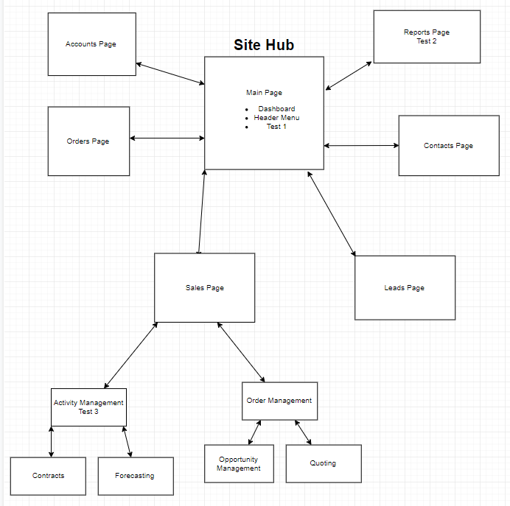

# ER Diagram for Salesforce

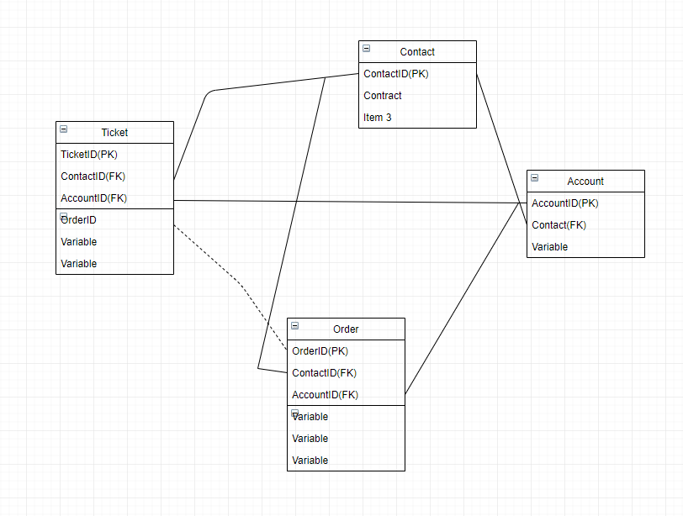

**Figure 2: UML Diagram**

# Model GUI

*Note: Screenshots are actual GUI examples from SalesForce CRM. Private company information has been redacted.*

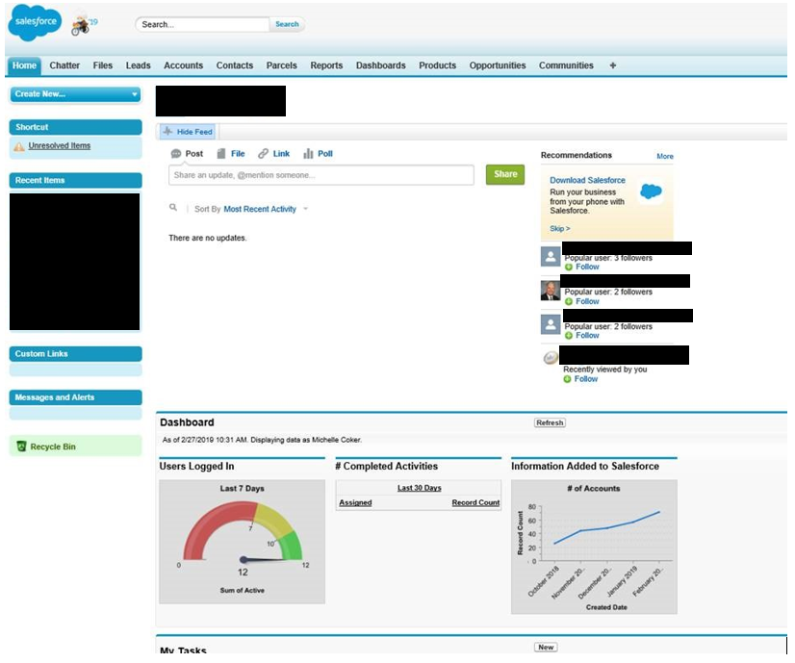

**Figure 3: Model GUI Mock-up**

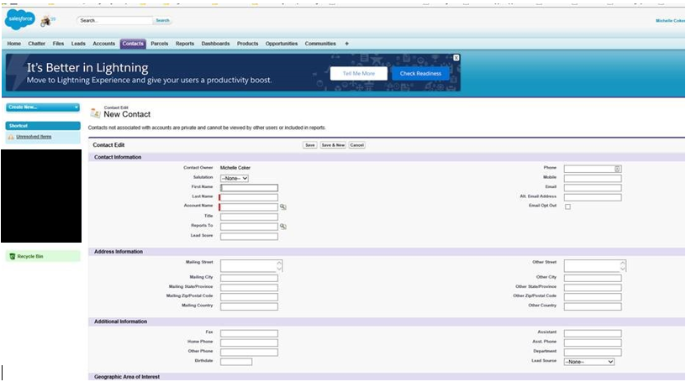

# Testing

# Waterfall Testing

The proposed testing solution will follow a step by step process through each of the chosen functional requirements, expanding when necessary to determine that each piece of the software works as intended.

# Functional Test

|  |
| --- |
| Requirement to be tested  To ensure the system operates on all needed browsers and systems |
| Preconditions: Conditions that must be present before test case can successfully run  We must have access to test systems within the compatibility list in order to test Salesforce access on them |
| Steps: The steps the tester must execute to test the feature.   1. Open the hosted site and subsidiary pages on PC, first using IE, then Chrome and Firefox 2. Repeat with Safari Browser 3. Test on mobile device with IE Chrome and Firefox 4. Test mobile app on Iphone and Android model phones |
| Expected results: Expected result given the wide use of Salesforce as it is a large scale company is that the application is usable across all platforms. Possible issues with mobile browser as Salesforce recommends mobile users use their dedicated app as opposed to web access. |
| Pass/Fail: Mark whether the test case passed or failed. The results can be compiled and used to determine if the application is ready for delivery/release.  Pass |

# Reporting Tool Test

|  |
| --- |
| Requirement to be tested  Salesforce Reporting tools must be able to provide both detailed low level reports as well as high level dashboards and summaries |
| Preconditions: Conditions that must be present before test case can successfully run  There must be enough test data imported into the system in order to generate viable reports. Dashboards can be created without this, but the displays will not be able to be tested without data |
| Steps: The steps the tester must execute to test the feature.   1. Ensure a certain amount of data has been imported into the system. Ideally this should be done after all data has been imported 2. Run OOTB reporting tools 3. Create test reports to run 4. Create test dashboards 5. Alter test data to check dashboards for updates |
| Expected results: Expected results and any side effects such as updating a database, writing to a file, etc.  It is expected that the OOTB reporting tools and dashboards will work without issue. There may be a learning curve for developing our own reports and executive dashboards depending on how customized our data uploads are |
| Pass/Fail: Mark whether the test case passed or failed. The results can be compiled and used to determine if the application is ready for delivery/release.  Pass |

# Activity Tracking Test

|  |
| --- |
| Requirement to be tested  Salesforce must properly track and hold all data on any visits and meetings with stakeholders and any member of the company |
| Preconditions: Conditions that must be present before test case can successfully run  Salesforce must be loaded with test case Stakeholders in order to ensure the Activity Management piece is functioning properly |
| Steps: The steps the tester must execute to test the feature.   1. Data import of contacts must be completed 2. A test contact should be created to go through the entire process 3. Run the contact through initial workflow and ensure all communication is documented 4. Test export and import of contact data 5. Ensure meeting tracking is functional 6. Test communication between Exchange server and Salesforce Cloud service |
| Expected results: Expected results and any side effects such as updating a database, writing to a file, etc.  It is anticipated that all activity tracking within the cloud will function without issue. Possible side effect of importing the data is that imported contacts will be missing important pieces that manual entry into the system will require, which could lead to communication issues with the Exchange Server |
| Pass/Fail: Mark whether the test case passed or failed. The results can be compiled and used to determine if the application is ready for delivery/release.  Initial fail until workaround for incomplete contact data is implemented |

# 

# Sources

“The Sales Hub by Salesforce” *Salesforce.com*, [www.salesforce.com/hub/sales](http://www.salesforce.com/hub/sales).

“The CRM Hub by Salesforce” *Salesforce.com*, [www.salesforce.com/hub/crm](http://www.salesforce.com/hub/crm).

“Data Loader” *Salesforce.com,* <https://help.salesforce.com/HTViewHelpDoc?id=data_loader.htm>

Storyboard Software used <https://www.draw.io/>

Screenshots pulled from PotlatchDeltics live CRM Salesforce system with permission, private information redacted out of courtesy